Saint Petersburg State University of INDUSTRIAL TECHNOLOGIES and DesignHIGHER SCHOOL of Printing AND MEDIA TECHNOLOGIES
2020 Annual Young Scientists Research Online Conference
Youth Science Innovations
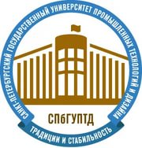
INTEGRATION PROCESSES
IN THE MODERN SOCIETY EVOLUTION
Tuesday, 7 April
Congratulations to the Conference winners

First Prize Anna Olimskaya, 1-GID-13. The perception of advertising with regard to ethical correctness: a student opinion survey.

Second Prize Daniil Budaev, 3-GIDA-5. The secret of Maria Corelli’s novel ‘The sorrows of satan’ (1895) success.

Third Prize Darya Tolmacheva, 1-GID-3. The features of the fashion houses development in Great Britain and Russia.

Audience Award Ksenia Makarovskaja, 3-GIDA-5. Educational podcasts market trends.

