Ярмухаметова Камила 3-ГИД-17
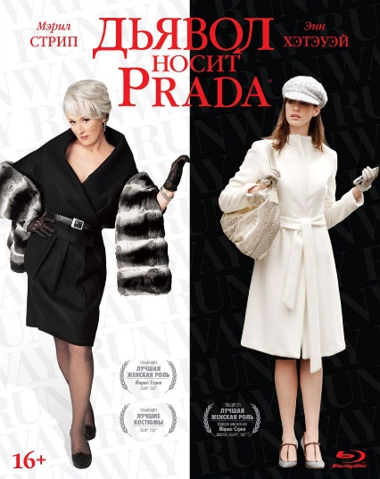
The Devil Wears Prada
The film I am reviewing is called ‘The Devil Wears Prada’. It is an adaptation of The Devil Wears Prada by Lauren Weisberger. It is a comedy-drama film directed by David Frankel and produced by Wendy Finerman. This film is a world blockbuster and has been nominated for prestigious awards.
It is still a cult film to this day and has entered the history of cinema and fashion. I would like to point out that all the details are given in the film, for example $1 million worth of clothing was used in the film, making it one of the most expensively costumed films in cinema history. Interesting fact, David Frankel and costume designer Patricia Field also created looks for the popular series ‘Sex and the City’ so they knew how to create a fashionable image thanks to their connections in the fashion industry. I am glad that the film showed both the good and bad sides of this industry. My favourite scene is when Miranda Priestly sarcastically and rudely explains to Andrea that behind the fashion magazine there is a huge amount of work by each employee, they decide what clothes people will wear, their work has a cultural significance for the whole world. However, it is not all about success and fame, it is a big sacrifice because fashion is Miranda’s life and she can't spend time with her family. Fortunately, Andrea decides what kind of personal life she needs. The story was inspired by US Vogue editor Anna Wintour who is strict with her employees.
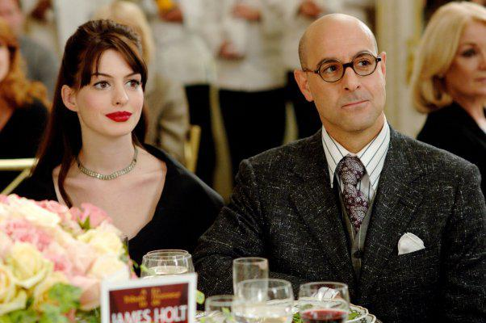
The most interesting characters in the film are fashion magazine editor Miranda Priestly played by Meryl Streep and Priestly's assistant Andrea Sachs played by Anne Hathaway, and my favourite character is art director Nigel Kipling played by Stanley Tucci because he helps Andrea with her style, he is smart, funny and kind man. The story is set in New York City, where Andrea Sachs an aspiring journalist lands a job as the personal assistant to Miranda Priestly the editor-in-chief of Runway magazine. Over the course of the story, Andrea develops dynamically and becomes just like her boss.
Sound effects add to the emotional scene. The music captures a contemporary urban sound. My favourite soundtrack is ‘Suddenly I See’ but it is not included in the official album an omission that disappointed many fans.
To sum up, this is my favourite film, it's worth watching. I didn't like that Andrea stayed with her boyfriend at the end of film, but the plot, visual picture and music are awesome.

